**Course Project Part 4 – Analysis**

**By: Payten Ivins, Kathryn DePalma, Tessa Klein**

**Professor Peña**

**November 7th, 2024**

**Silhouette Collective**

**Introduction**

Silhouette Collective is a fashion concierge business that provides a highly personalized shopping experience to each and every customer. We collect personal information from each client, such as their clothing sizes, brand preferences, favorite colors, and item preferences to create a customer profile that is assigned to one of our experienced shoppers within the company. The shopper can then shop for specific events or just singular items per the customer’s request. As a new company, we have decided to perform this analysis to get a feel for our earnings and scope within the market thus far. This analysis offers key insights into our performance across various products, markets nationwide, and earnings by product. We can use these key insights to drive our future business decisions surrounding expansion into more markets, our product offerings, as well as our criteria for selecting clothing. As our stakeholders, we hope this analysis reassures you of our potential as a business and our bright future within the online shopping industry. While we have had many successes, as seen in this analysis there is always room for improvement and we look forward to expanding Silhouette Collective and furthering our success.

**Key Findings and Recommendations**

**Revenue by State – Map**

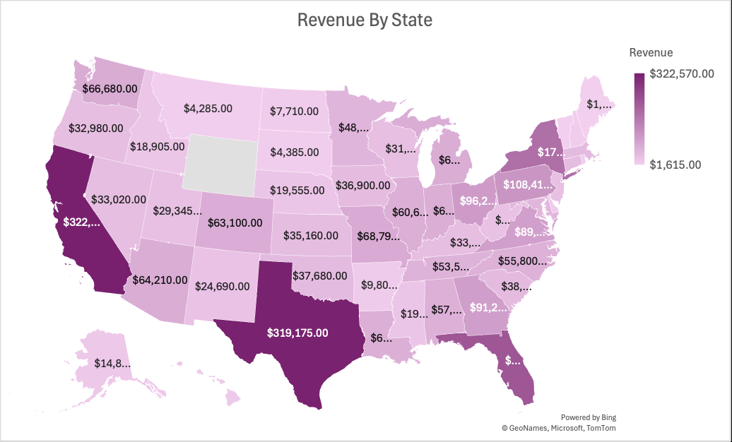

**Key Findings**

We wanted to look at which states produced the most revenue and what states we need to invest more money into. We see the top three states are California ($322,570), Texas ($319,175), and Florida ($223,820). While the bottom three are Rhode Island ($4,345), Maine ($1,750), and Vermont ($1,615). It makes sense the top three states are generating more revenue based on the population size in each of their states, but also, we see the bottom three are all based on the east coast.

**Recommendation**

From the findings above, we as a company recommend to invest more money specifically on the east coast. How we could do that is by either increasing our marketing or doing annual surveys to our customers in that region. We as a company can add more funding into marketing by having customer sign up for texts messages or emails. For the annual surveys if customers add their numbers or email into that system prior, we can ask questions about what products these customers want to see or bring back based on season. These results will vary because customers in regions who experience winter may want different items than others who have consistent weather all year round.

**Profit by Year**

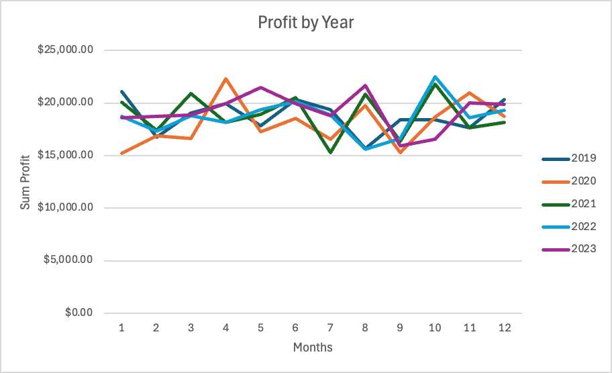

**Key Findings**

The Profit by Year line chart analyzes the profit from 2019 to 2023. An important year to note is 2020 as that introduces the effect the Covid-19 pandemic had on our company’s profit. The profit for 2020 dramatically jumps starting at March when the pandemic started. As of March, customers were confined to their homes which can explain the dramatic jump in profit from March to April. As it continues, the profit dramatically drops going into May when customer’s income slowed as they were not working. This drop can is assumed due to customer’s not wanting to spend additional money when they are not making a steady income. Looking at the profit as a whole, the company noticed that there is a consistent low profit in the beginning of the year from months January to March. There is a dramatic increase in profit around the time of Halloween as customers are shopping to create customers. Profit is also consistently higher around thanksgiving and Christmas as customers are shopping for gifts to give their loved ones. Across all 5 years there is a consistent drop in profit from August to September.

**Recommendation**

The first recommendation from this graph is related to the drop in profit from August to September. To increase profit here our company will create special deals during these months to hopefully drive-up profit and incentivize customers to do their holiday shopping earlier. In addition to the holiday deals, we can also create fall deals as clothing companies are entering into the winter season. Our company can also expand the product’s we offer to include more summer clothing items to hopefully drive-up profit during the end of summer/ beginning of fall since we currently only offer winter type of items. As we increase the different product types we offer, our marketing team can ensure our clients are made aware of these changings by sending new product portfolio emails out broadcasting the newer items we have acquired.

**Revenue and Profit by Event Type**

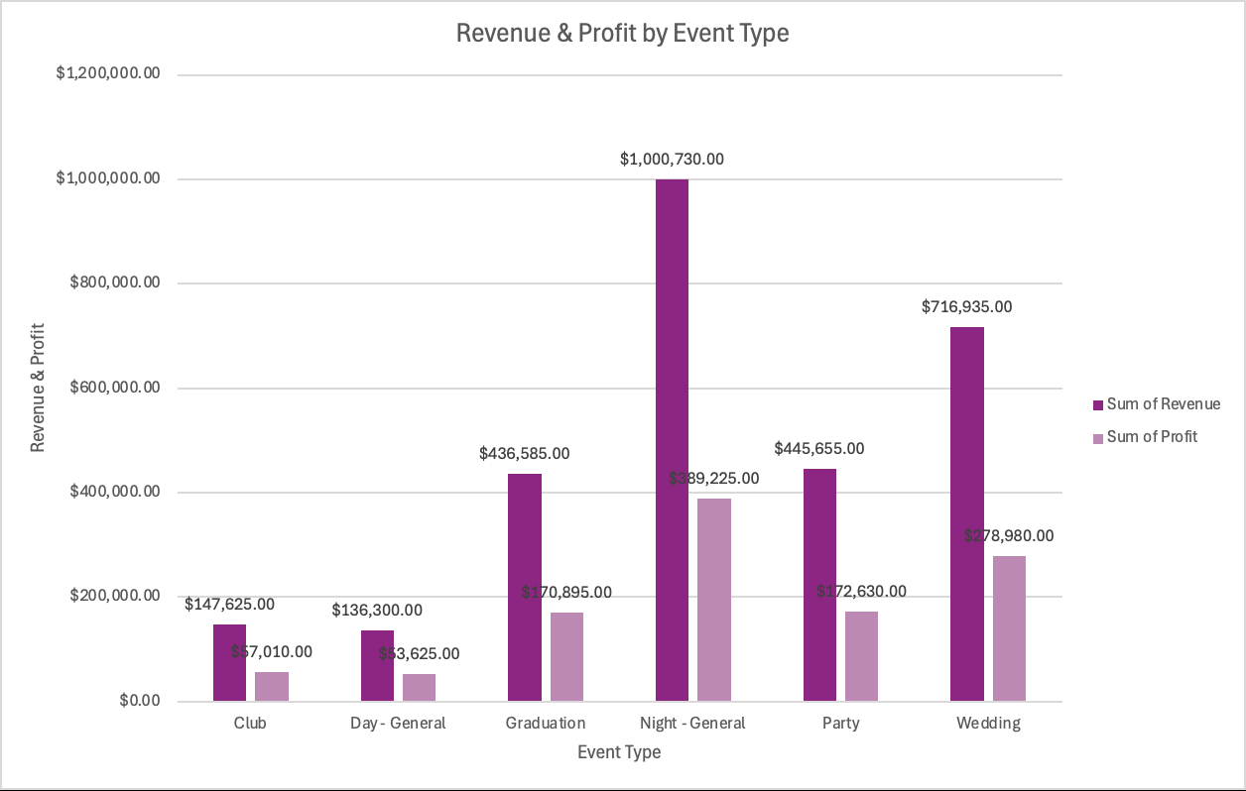

This clustered column chart visualizes the revenue and profit for each Event Type we offer to our customers as a criterion for shopping. The Event Types we offer are Club, Day-General, Graduation, Night-General, Party, and Wedding. Since we require that each customer provides an Event Type with their purchases, it is important we track which of the Event Types we offer drive the most traffic and which are not highly ordered. The Club category earns the least, around $147,600 while costing us around $90,000, leading to a profit of only $57,010. Our highest earning category is Night-General, with a revenue of around $1,000,000, costing us around $610,000 to offer these products, resulting in a profit of $389,225.

**Recommendation**

Based on these Event Type findings, we can tailor our product offerings to provide more options for the Event Types that bring us the most revenue, such as Night-General and Wedding, while limiting our costs for those that do not drive a lot of revenue, such as Club and Day-General. We can reduce these costs by diversifying our products for this category, but with less expensive products for us to offer. By diversifying our offerings, we can drive more traffic for these categories at a reduced cost to us, leading to an increased profit margin.

**Orders by Item**

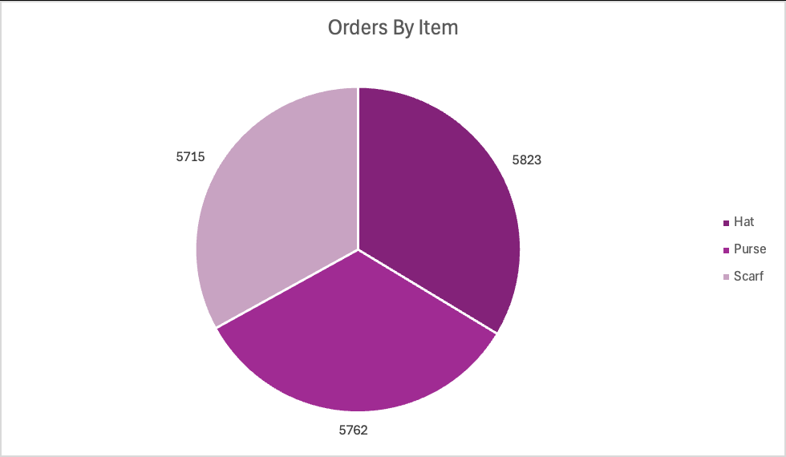

**Key Findings**

What we found when analyzing the number of orders by item was very straight forward. As a company we do not offer many items but we see that hats are the number 1 item being bought, but the other two items are not far behind. As a smaller company we started out with less items to see if they would be successful on the market first before expanding.

**Recommendations**

From our findings, we want to recommend expanding our item selection here soon. Once we get results from our surveys mentioned above it can give us an idea of what items consumers want to see and which ones they do not. After that, when the survey results are analyzed, we hope to find out what items can go to specific locations and make sure we are constantly regulating the wants and needs of consumers nationwide.